***RR KABEL CALL CENTER REPORT ANALYSIS***

***Sample Data***:  
 call_date phone_number_dialed status user full_name \  
0 2025-05-01 09:00:19 9690273024 ANSWER 29756 Mohit   
1 2025-05-01 09:00:30 8808141708 ANSWER 32739 Deepak Rajbhar   
2 2025-05-01 09:01:10 6201597399 ANSWER 32991 Nibha Kumari   
3 2025-05-01 09:01:26 9721636066 ANSWER 34082 Abhilasha Sharma   
4 2025-05-01 09:02:04 6370025499 ANSWER 34631 sahil Ansari   
  
 campaign_id vendor_lead_code source_id list_id gmt_offset_now \  
0 Luminous_helpline_1 Luminous_Callmeenu VDCL 998 -5   
1 RR_CABLE_HINDI WELCOME_RRCABLE VDCL 998 -5   
2 Luminous_helpline_1 Luminous_Callmeenu VDCL 998 -5   
3 RR_CABLE_HINDI WELCOME_RRCABLE VDCL 998 -5   
4 Luminous_helpline_1 Luminous_Callmeenu VDCL 998 -5

***EACH CAMPAGN ID ANSWERED AND DROPPED CALLS :***

|  |  |  |
| --- | --- | --- |
| **status** | **campaign_id** | **Count of status** |
| **Answer** | Lumi_Bengoli | 1 |
|  | luminious_helpline_5 | 1509 |
|  | Luminious_helpline_6 | 281 |
|  | Luminious_helpline_7 | 231 |
|  | Luminous_helpline_1 | 25165 |
|  | Luminous_helpline_2 | 951 |
|  | Luminous_helpline_3 | 453 |
|  | Luminous_helpline_4 | 319 |
|  | Luminous_helpline_ca | 5 |
|  | RR_Bengoli | 1079 |
|  | RR_CABLE_ENG | 941 |
|  | RR_CABLE_HINDI | 20386 |
|  | RR_CABLE_MALYALAM | 328 |
|  | RR_CABLE_Tamil | 238 |
|  | RR_kannad | 174 |
|  | RR_telgu | 118 |
|  | RRMOBILE | 393 |
| **Answer Total** |  | **52572** |
| **DROP** | luminious_helpline_5 | 10 |
|  | Luminious_helpline_6 | 3 |
|  | Luminous_helpline_1 | 878 |
|  | Luminous_helpline_2 | 8 |
|  | Luminous_helpline_3 | 2 |
|  | Luminous_helpline_4 | 1 |
|  | Luminous_helpline_ca | 1 |
|  | RR_Bengoli | 8 |
|  | RR_CABLE_ENG | 9 |
|  | RR_CABLE_HINDI | 865 |
|  | RR_CABLE_MALYALAM | 2 |
|  | RR_CABLE_Tamil | 7 |
|  | RR_kannad | 2 |
|  | RR_telgu | 1 |
|  | RRMOBILE | 13 |
| **DROP Total** |  | **1810** |
| **(blank)** | (blank) |  |
| **(blank) Total** |  |  |
| **Grand Total** |  | **54382** |

***EACH VENDOR CUSTOMER INTERACTION SUMMARY :***

|  |  |  |  |  |
| --- | --- | --- | --- | --- |
| **vendor_lead_code** | **Count of user** | **Sum of length_in_sec** | AVG TIME | TOTAL AVG |
| (blank) |  | 186.8385127 | 204.16 | 186.83 |
| WELCOME_RRCABLE | 6383 | 989459 | 169.77 |  |
| RRMOBILE | 18179 | 3086408 | 154.97 |  |
| Luminous_Callmeenu | 29820 | 6084785 |  |  |
| **Grand Total** | **54382** | **10160838.84** |  |  |

***Each Agent Performance:***  
  
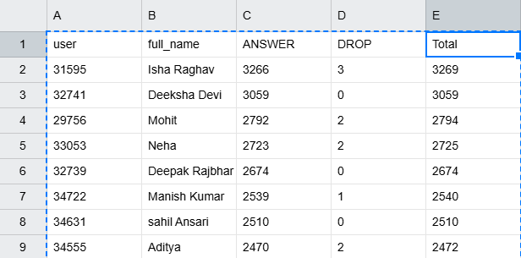

(FOR FULL DETAIL, REFER Agent_performance_summary (1).csv

***Each Campaign Summary :***  
  
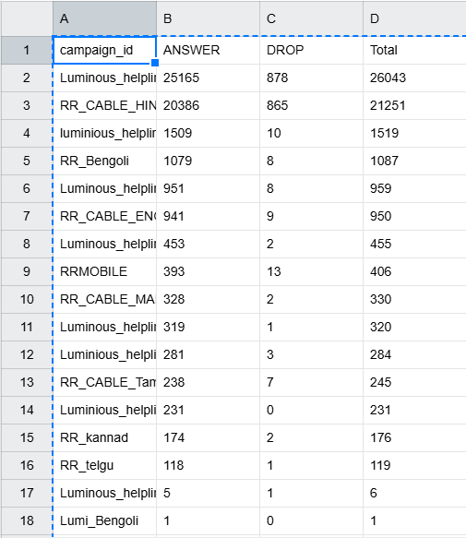  
  
Refer the (campaign_performance_summary.csv)

***Each campaign performance in responding of dropped calls:***

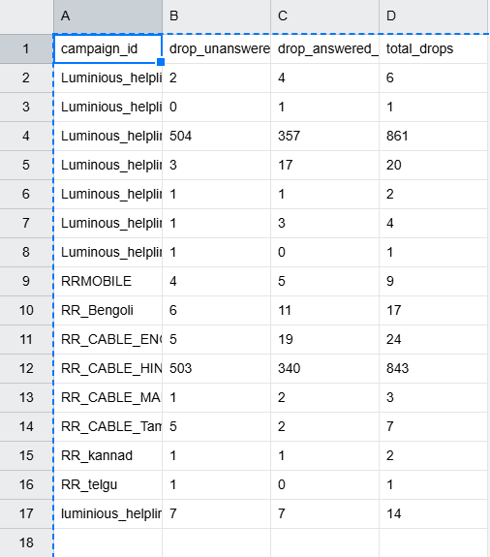

Refer(campaign dropped call summary.csv) file

***Each campaign response time on drop calls :***  
  
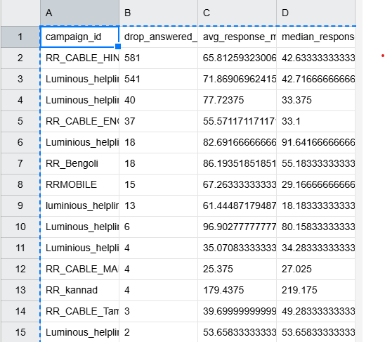

***Refer the campaign response time summary.csv:***

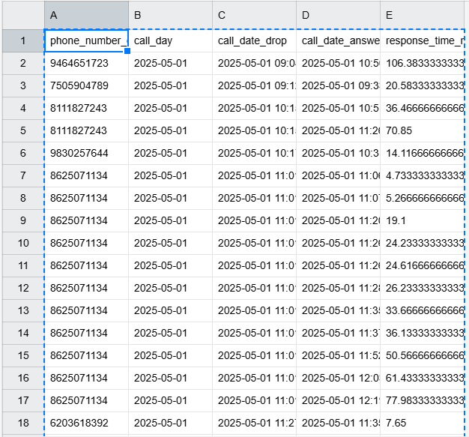

Refer the dropped calls same day answered.csv



***DETAILS ABOUT THE UNANSWERED DROP CALLS :***

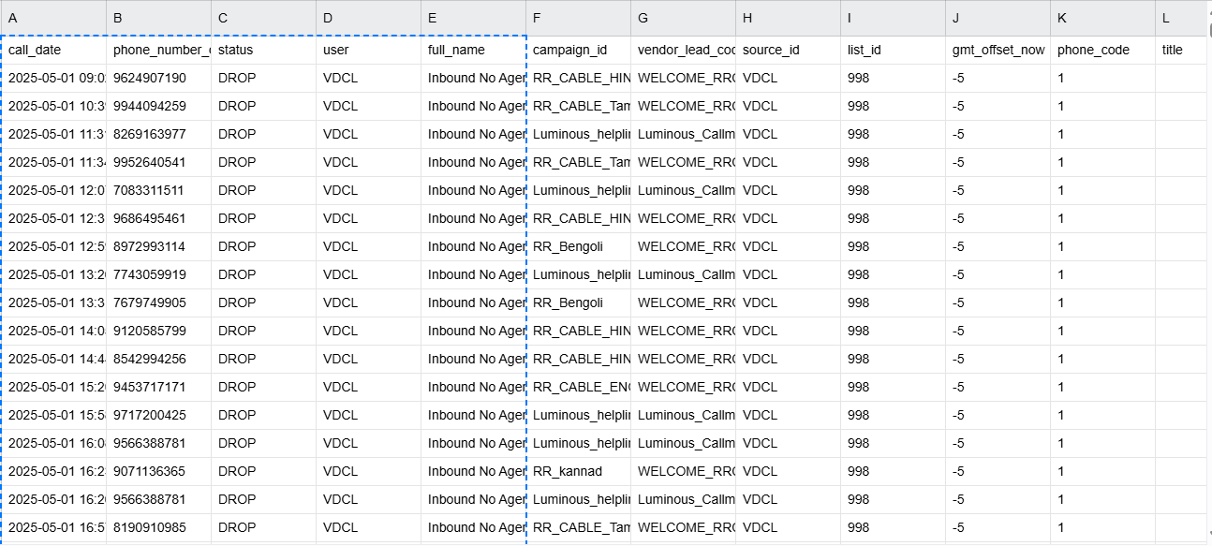

***Each caller complete interaction analysis data :***  
  
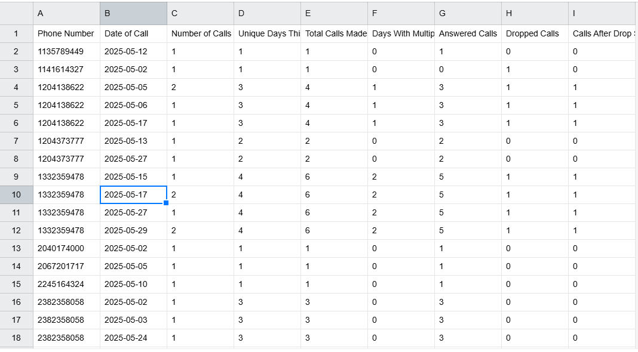

Refer the (daiy_calls_summary.csv)

***Daily call by user in descending order :***  
  
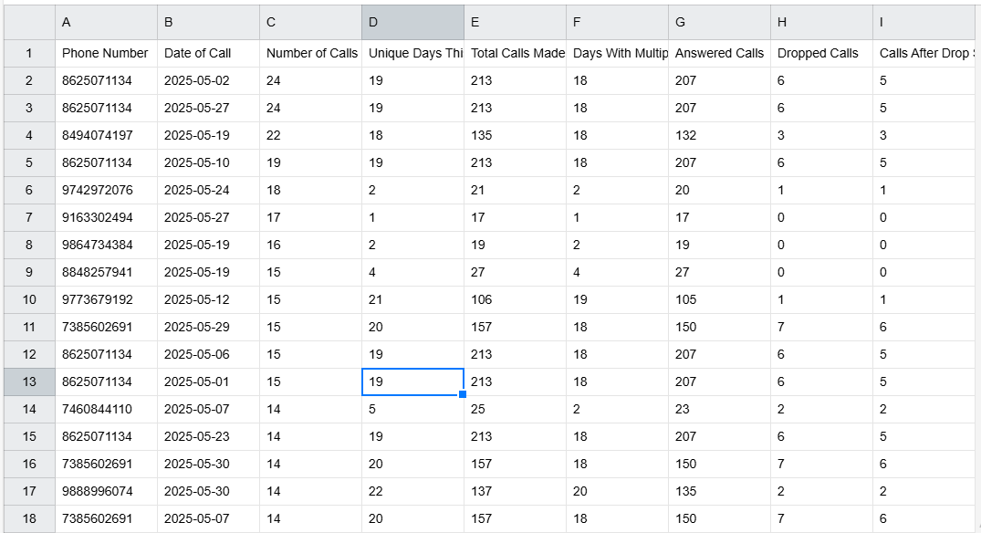

Refer the (daily calls summary sorted.csv)

***Graphical analysis of the Customer interaction***

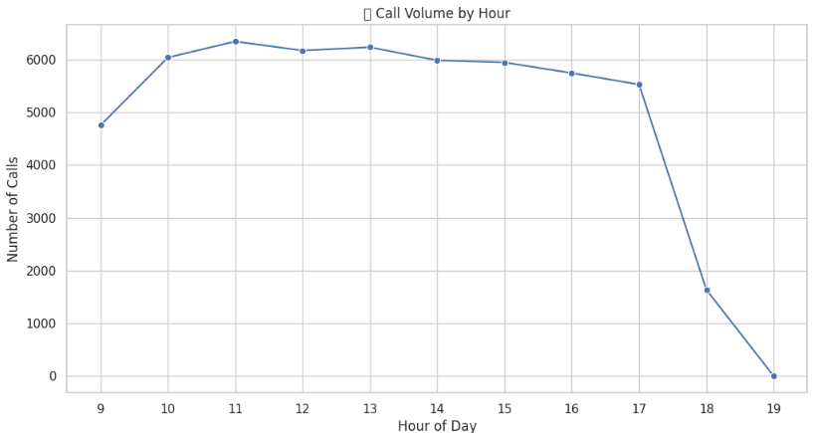

### **Call Volume by Hour**

* **What it shows**: Number of calls received during each hour of the day.
* **Insights**:
  + Peak call hours are between **10 AM and 1 PM** (with the highest around **11 AM**).
  + Call volume sharply drops after **5 PM**, especially at 7 **PM**, which could indicate reduced service hours or lower demand.

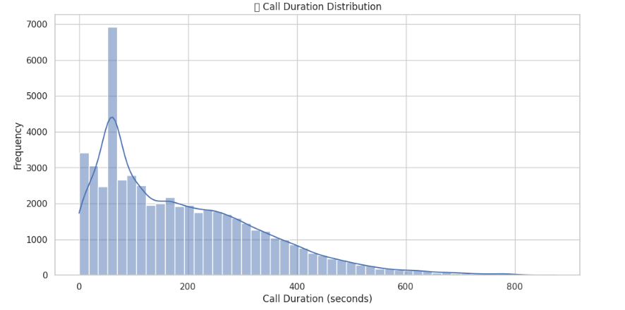

### **Call Duration Distribution**

* **What it shows**: Histogram of call durations (in seconds).
* **Insights**:
  + Peak durations are clustered around **20–60 seconds**.
  + There’s a **secondary spike near 120–150 seconds**.
  + As with the response time, this distribution is also **right-skewed**, indicating that while most calls are short, some are significantly longer.

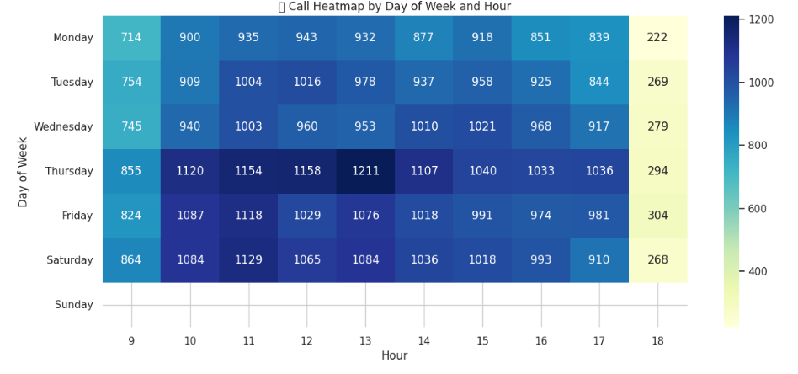

### **Call Heatmap by Day of Week and Hour**

* **What it shows**: Call volume distributed across **day of week** and **hour of day**.
* **Insights**:
  + **Thursday** has the **highest call traffic**, particularly from **10 AM to 2 PM**.
  + Lowest volume seen after 6 PM and on **Sunday** (possibly non-working or low activity day).
  + Consistent call demand on weekdays from **10 AM to 4 PM**.

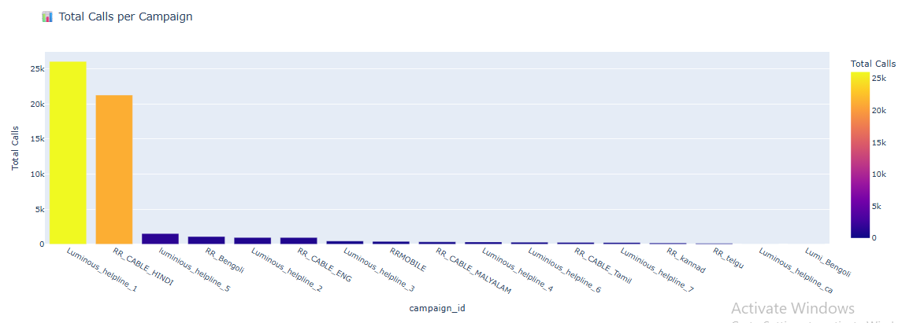

### **Total Calls per Campaign**

* **What it shows**: Total calls received by each campaign.
* **Insights**:
  + Luminous_helpline_1 and RR_CABLE_HINDI dominate with **over 20k** and **21k+ calls** respectively.
  + Most other campaigns have far fewer calls (less than 3k).
  + Indicates **heavier reliance** or popularity of certain campaigns.

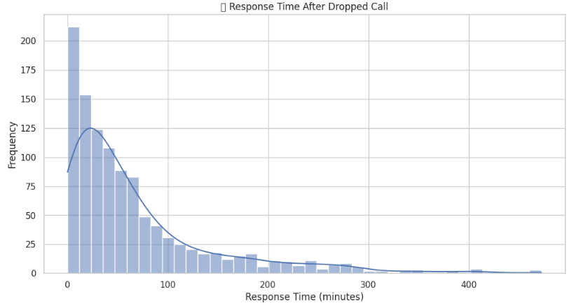

### **Response Time After Dropped Call**

* **What it shows**: Histogram of the time taken to respond after a call is dropped.
* **Insights**:
  + Most responses happen within **0 to 50 minutes**.
  + There’s a **long tail**, meaning a few cases have very delayed responses (even up to 400+ minutes).
  + The distribution is **right-skewed**, indicating response times are usually fast but sometimes extremely delayed.

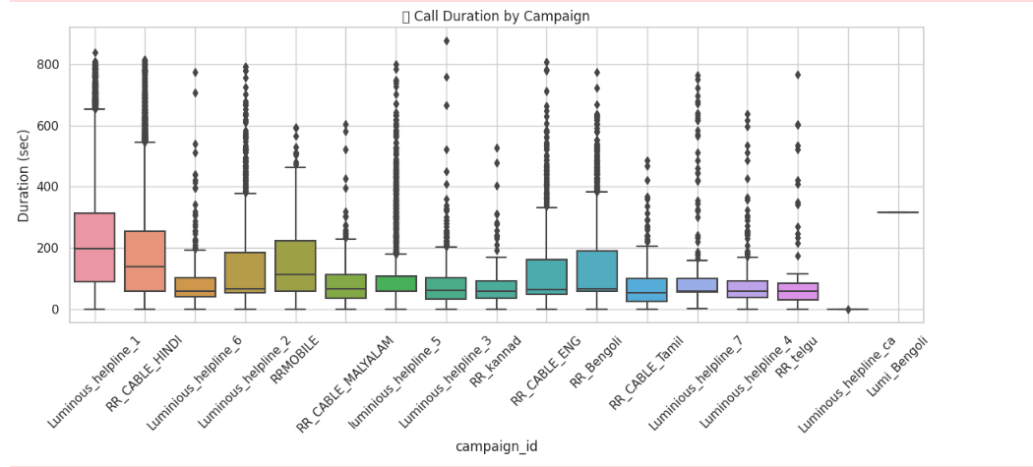

### **Call Duration by Campaign**

* **What it shows**: Boxplot of call durations for each campaign.
* **Insights**:
  + Luminous_helpline_1 has **longer average durations** and **more variability**.
  + Several campaigns like Luminous_helpline_4, RR_Telgu, and Luminous_helpline_ca have **shorter** and **less variable** durations.
  + Outliers present in almost all campaigns, suggesting some unusually long calls.

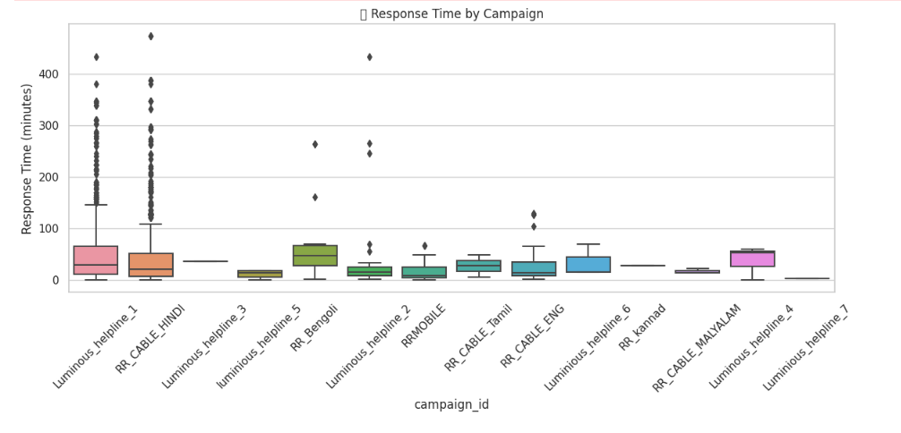**Response Time by Campaign – Summary**

* **Luminous_helpline_1** and **RR_CABLE_HINDI** have the **highest and most variable** response times, with many outliers.
* **Luminous_helpline_3**, **5**, and **7** show **quick and consistent** response times.
* **RR_Bengoli** and **RR_CABLE_ENG** have **moderate response times** with some variation.
* **RR_Kannad** and **Luminous_helpline_4** have **uniform and minimal** response delays, indicating strong consistency.